Mock Interview Process
PLEASE DIRECT ALL QUESTIONS REGARDING MOCK INTERVIEWS TO SOPHIA HERNANDEZ – PROGRAM TECHNICHIAN

- Students take the Math and Customer Service Quiz (have two chances to pass quiz)
- Students take and pass all 4 HOC courses
- All students who passed the 4 HOC courses and both quizzes will be invited to the LA Chamber of Commerce Mock Interview date
Details
- Mock interviews will be held at the Los Angeles Chamber of Commerce office (350 S. Bixel St. Los Angeles CA 90017)
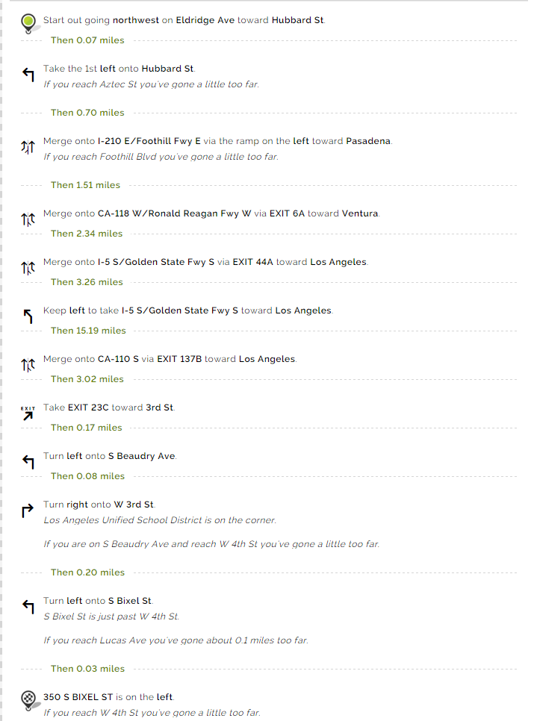
- All eligible students will be receiving an email directly from LA Chamber of Commerce with all the details
- All students who pass the mock interview will receive a Los Angeles Chamber of Commerce Job Readiness Certificate as well as the Job Readiness Digital Badge

Additional Information
- Math Quiz covers topics like Addition with Decimals, Number Sequence, Percentages, Rounding, Subtraction, Multiplication and Division. Some examples are found below.
- Customer Service Quiz covers topics like Dealing with Difficult Patients/Customers, Customer Care, Greeting and Dealing with Mistakes or Misunderstandings.

- Round 5467.894435 to the nearest tenth.
- Sophia ordered 15 boxes of flowers. She received 9 in the first shipment. How many is she expecting in the second shipment?
- 4.5 x 3.6
- How would you complete the number sentence: 34 + ___ + 15 = 74
- What number is missing: 5,15,25,35,___, 55,65

