Physical Therapy (DPT) Prerequisites
Los Angeles Mission College does not offer a Physical Therapy program. However, students may meet requirements with an Associate’s degree in Health Science or Kinesiology. Typically, students will pursue a bachelor’s degree in a related field and continue in a Doctor of Physical Therapy program. Please consult with a counselor for more information.

Core Courses | Prerequisites
Biology 6 & 7 | English 28 or ESL 8 AND Chemistry 51,65 OR 101 AND Math 123C or 125
Chemistry 101 & 102 | Chemistry 65 AND Math 123C or Math 125
Anatomy 1 | English 28 or ESL 8 and Biology 3 or 5
Physiology 1 | Biology 3 or 5, Anatomy 1, AND Chem 51, 65 OR 101
Physics 6 & 7 OR  Physics 36, 37,38 | Speak to the STEM Counselor to discuss which physics will fit your interested program
Math 227 | Math 123C or Math 125 or Math 134
Additional Basic Requirements (for most PT programs)
English 101 & 102
Psychology 1
Sociology 1
Communication 101
To increase chances of admission, students should:
- Apply to more than one PT program
- Complete all coursework with a grade of “B” or better
- Maintain a minimum cumulative GPA of 3.5
- Maintain a minimum GPA of 3.5 in core courses
- Attend information sessions for each individual PT program if available

Local (California) Physical Therapy Programs
Azusa Pacific University Cal State Fresno |  | Cal State Long Beach
Loma Linda University | Cal State Sacramento | Cal State Northridge
Mount Saint Mary’s University | Samuel Merritt University | Chapman University
San Francisco State University | University of Southern California | San Diego State University
Western University of Health Sciences | University of St. Augustine for Health Sciences | UC San Francisco
University of the Pacific | West Coast University

Physical therapists (PTs) are health care professionals who diagnose and treat individuals of all ages, from newborns to the very oldest, who have medical problems or other health-related conditions that limit their abilities to move and perform functional activities in their daily lives.
PTs examine each individual and develop a plan using treatment techniques to promote the ability to move, reduce pain, restore function, and prevent disability. In addition, PTs work with individuals to prevent the loss of mobility before it occurs by developing fitness- and wellness-oriented programs for healthier and more active lifestyles.
Physical therapists provide care for people in a variety of settings, including hospitals, private practices, outpatient clinics, home health agencies, schools, sports and fitness facilities, work settings, and nursing homes.
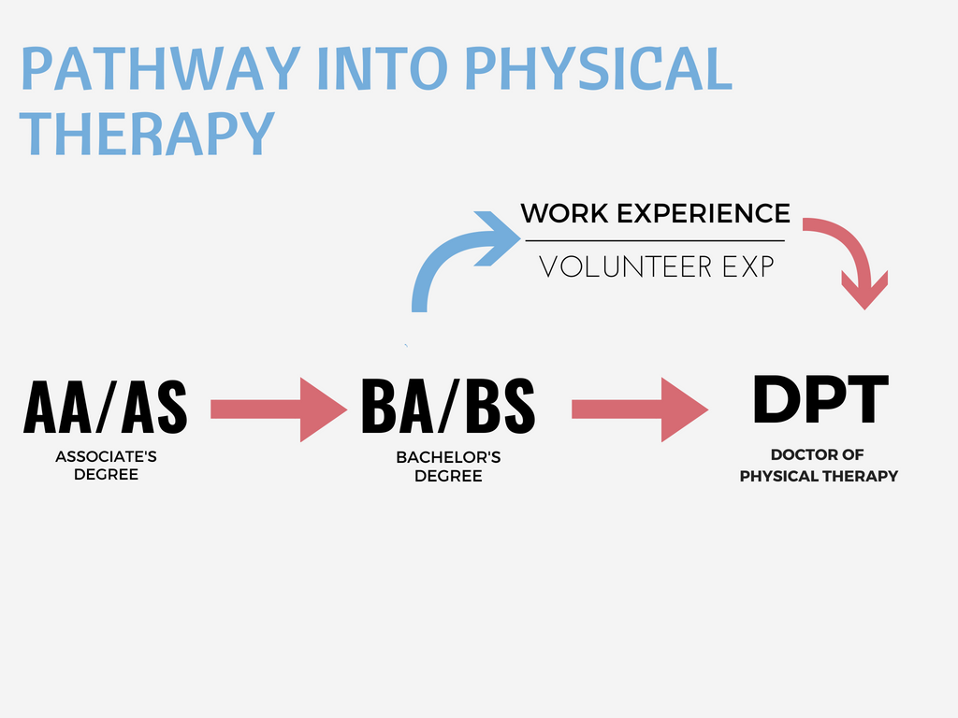

* Gaining additional Work Experience can strengthen an application
**DPT programs may have different requirements and can change at any time. For the latest information or to create a plan, please make an appointment with the STEM Counselor.

