MINI SYMPOSIUM 2022
STEM, Health, and Fitness:
From Education to Employment

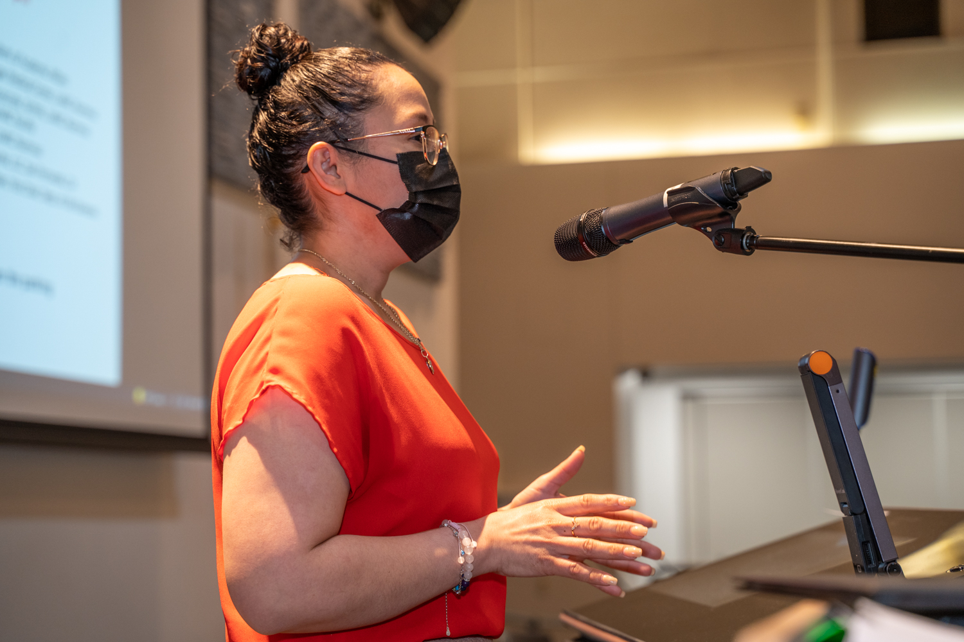
March 18, 2022
On Friday, March 18th, 2022, the Life Science Department at Los Angeles
Mission College held its 2n annual STEM, Health, and Fitness: From
Education to Employment Mini Symposium. The event aims to educate
and offer information in STEM and Health, and various careers within
these fields. Over 200 high school and college students, and community
members attended the event. The event offered all attendees the
Opportunity to hear the experience and journeys of several Dedicated
speakers working in multiple fields such as Nursing, Biotechnology,
Biochemistry, and Athletics.

Among the speakers was former LAMC graduate Odet Alfaro, who earned
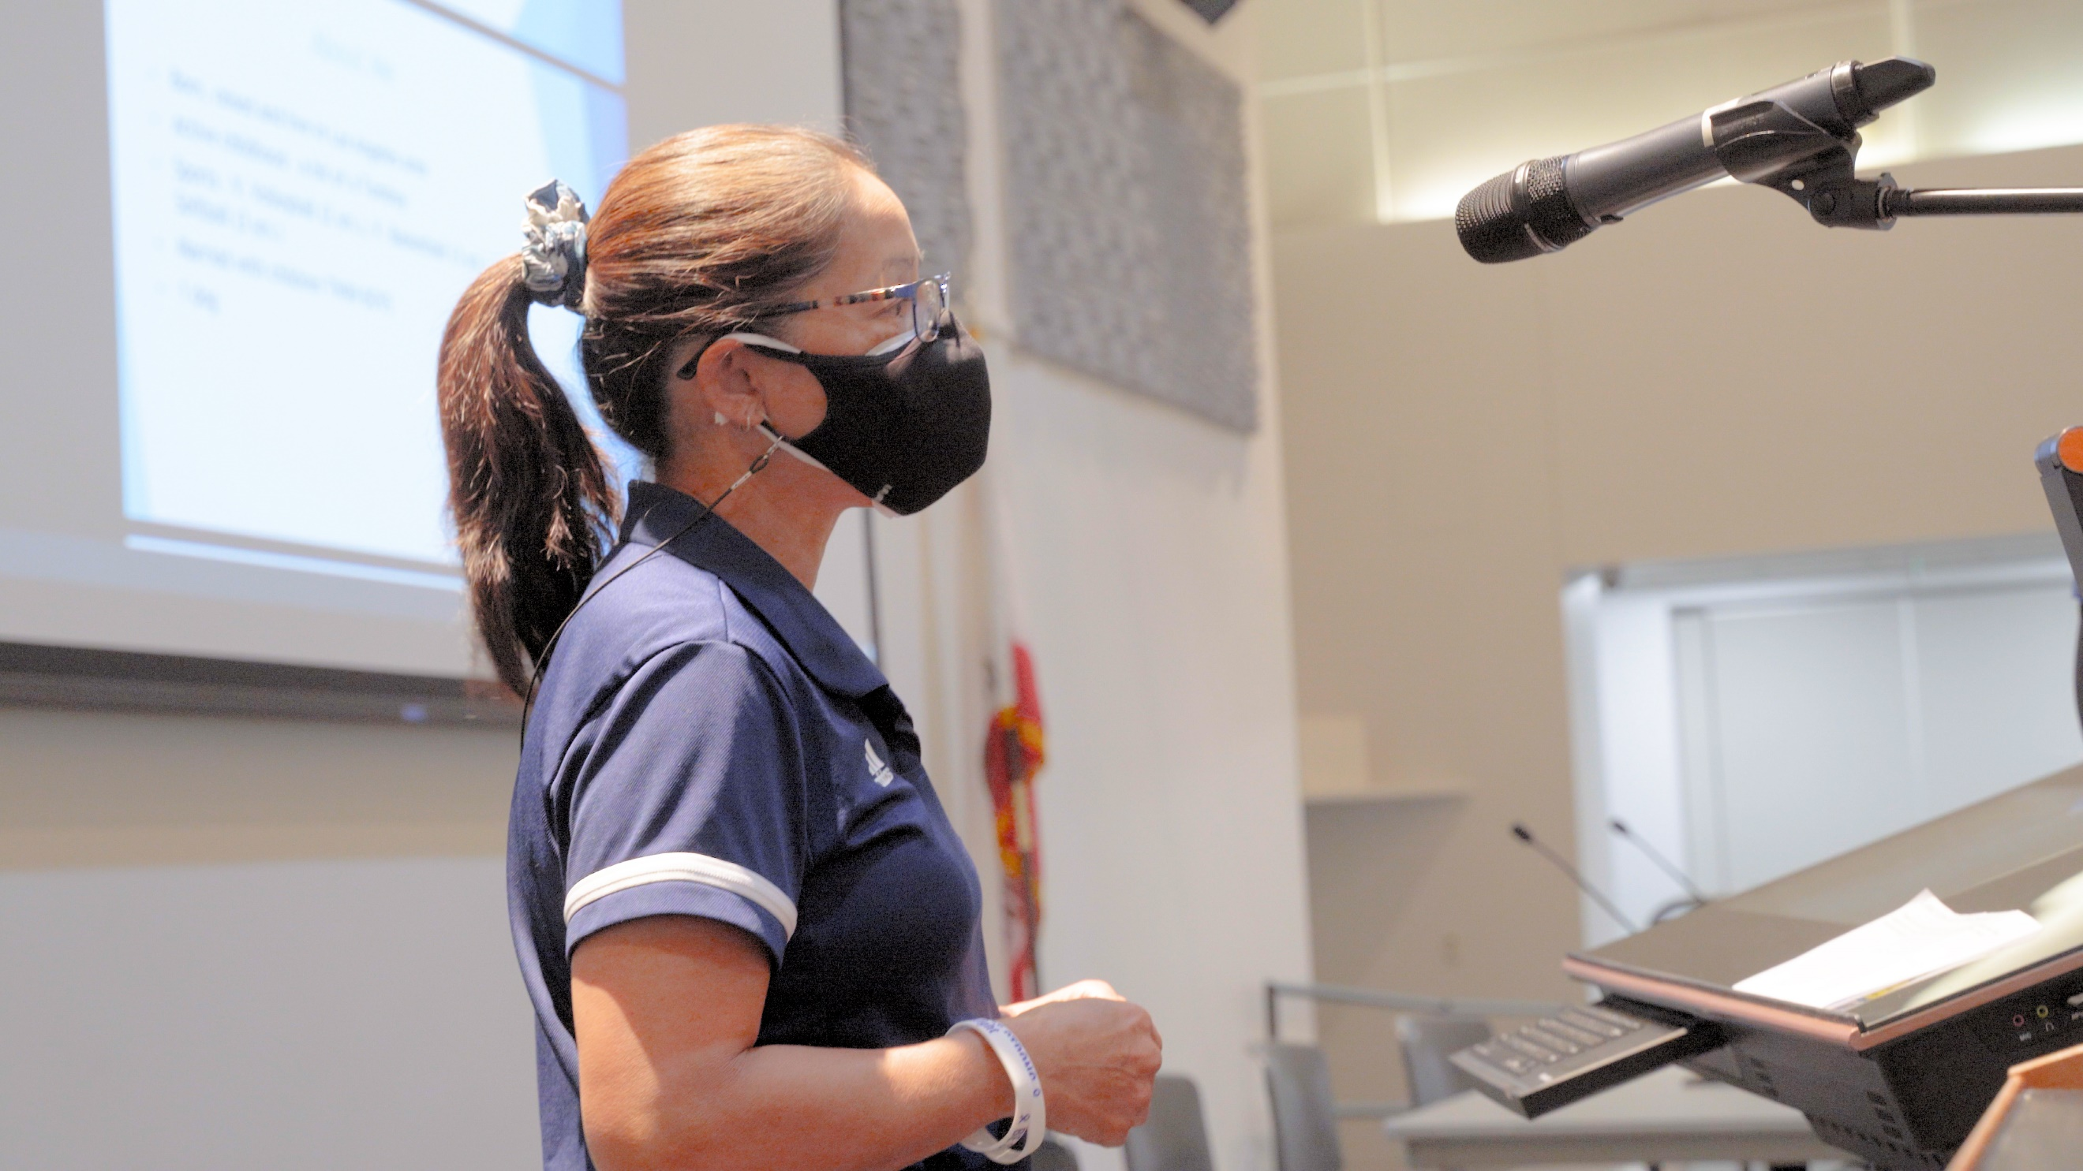
her AS in Biotechnology. She was able to speak on the impact the program
had on her and her current position as a Biomanufacturing associate at
Grifols Biological. Taryn Fowlds, a Clinical Nurse at Ronald Reagan UCLA
Medical Center, shared her experience as an LAMC student and crediting
her mentorship at LAMC for helping her prepare for a career as an RN.
Jesus Iniguez, one of LAMC’s own professors and also an LAMC
graduate, spoke eagerly about the opportunities available to students that
wish to pursue a career in Biochemistry. He shared his experience of
his pursuit to earning a PhD, and his journey as an LAMC student.
Tresha San-Martin, an Athletic Trainer, at LAMC, spoke to the attendees
about her journey as a trainer, and as a kinesiology professor at LAMC.
Lastly, Mario Solaris, an operating manager at Pharmavite, motivated
attendees about the duties he performed in the field of pharmaceutical
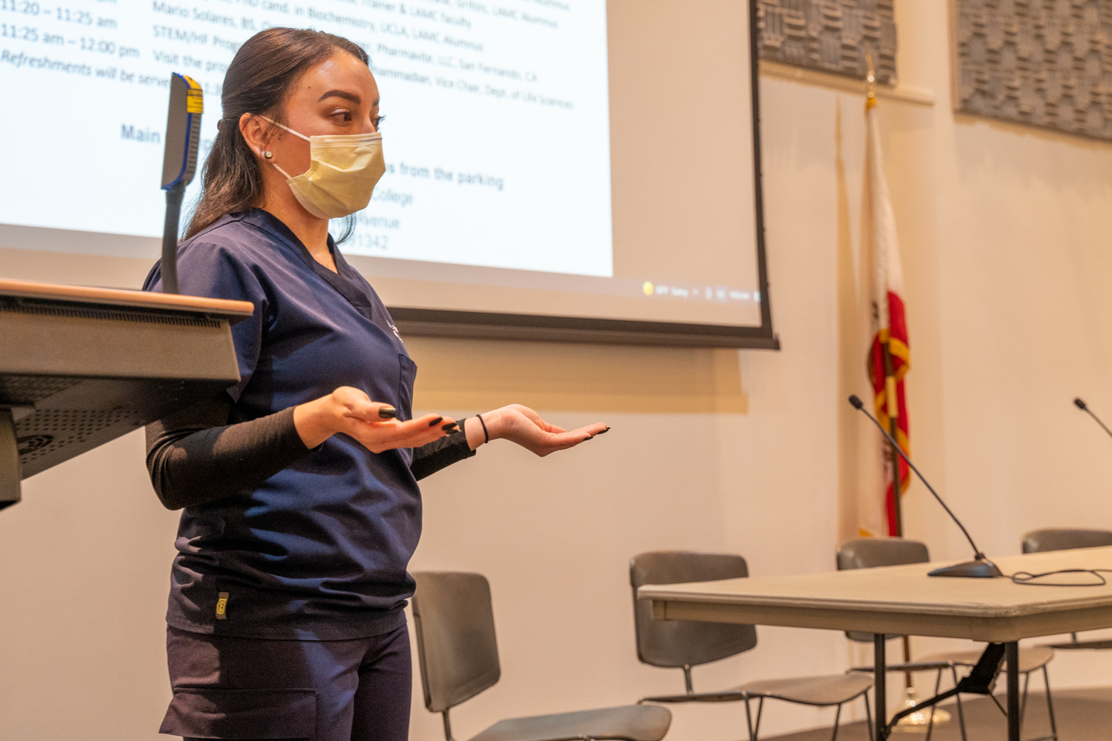
and nutraceutical industries.

Towards the end, attendees had the opportunity to visit several event
tables for networking possibilities, and speak to several LAMC
support programs. They were also able to have one on one interactions
with the speakers, and address any additional questions they may have.
Many of the attendees looked excited and eager about their careers of
interest and motivated to continue their education. The post-event survey
results showed that the attendees benefited greatly. In response to
“What elements of the STEM, Health, Fitness: Mini Symposium
were most valuable to your learning?” most attendees responded
that they enjoyed how the speakers spoke about their daily lives as
professionals. They also mentioned how they enjoyed the conversation
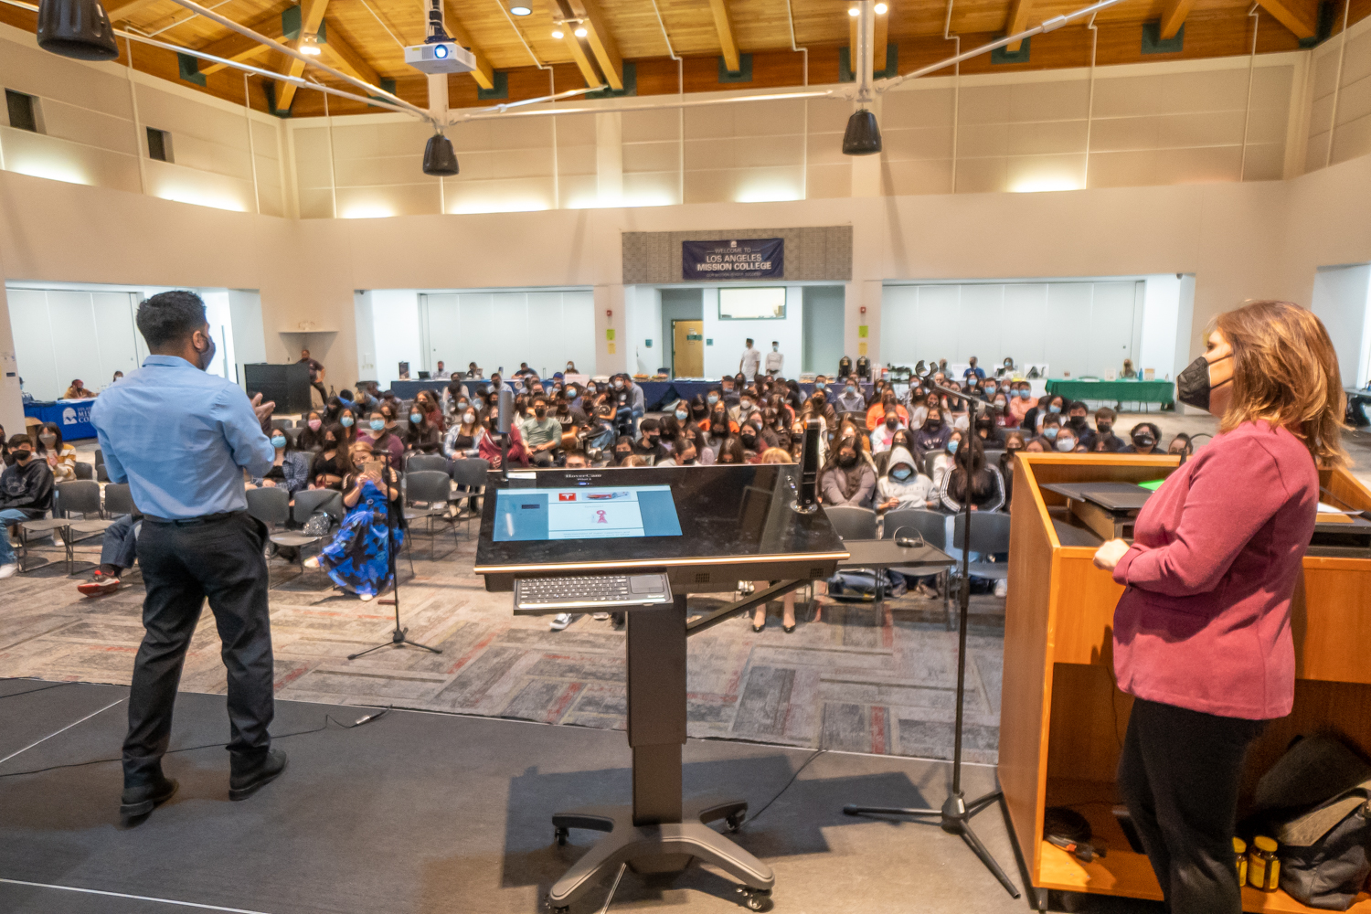
they had with the speakers and would like to connect further.
Overall, the event was able to offer guidance, opportunity, motivation,
and insight to what fields like STEM and Health have to offer.

